FULL STACK DEVELOPMENT WITH MERN
PROJECT DOCUMENTATION
DARSHANEASE – TEMPLE DARSHAN TICKET BOOKING SYSTEM

Submitted By
S. No | Name
1 | Mounika Sai
2 | Thirumuru Hasini
3 | Mathakala Hariprasad
4 | Poornesh Kumar
5 | Medagiri Praveena

Department
Computer Science & Engineering
College
Narayana Engineering College, Nellore
Academic Year
2026–2027

ABSTRACT
Abstract
Darshan Ease is a full-stack web application developed using the MERN (MongoDB, Express.js, React.js, and Node.js) technology stack to simplify the temple darshan ticket booking process. The application enables devotees to browse temples, view available darshan slots, and book tickets online without waiting in long queues.
The system provides secure user authentication using JSON Web Tokens (JWT), allowing devotees to register, log in, and manage their bookings efficiently. Administrators can manage temples, users, organizers, and bookings through a dedicated dashboard, while organizers can manage darshan slots and booking activities.
The frontend is developed using React.js to provide a responsive and interactive user interface, while the backend is implemented using Node.js and Express.js to provide RESTful APIs. MongoDB is used as the primary database to store temple details, user information, booking records, and slot availability securely.
Darshan Ease aims to improve the overall temple visit experience by reducing waiting time, minimizing overcrowding, ensuring transparency in ticket allocation, and providing a reliable digital platform for temple administration.
Keywords: MERN Stack, React.js, Node.js, Express.js, MongoDB, Temple Booking, JWT Authentication, REST API.

TABLE OF CONTENTS
S. No | Contents
1 | Introduction
2 | Project Overview
3 | Architecture
4 | Setup Instructions
5 | Folder Structure
6 | Running the Application
7 | API Documentation
8 | Authentication
9 | User Interface
10 | Testing
11 | Screenshots / Demo
12 | Known Issues
13 | Future Enhancements
14 | Conclusion
15 | References

CHAPTER 1
INTRODUCTION
1.1 Introduction
The rapid advancement of information technology has transformed the way people access services across various sectors. Online reservation systems have become an integral part of modern society, enabling users to perform tasks conveniently from any location. Religious institutions are also adopting digital solutions to improve service quality and efficiently manage large numbers of devotees.
Temple visits hold great spiritual significance, and millions of devotees visit temples every year. During weekends, festivals, and special occasions, devotees often experience long waiting queues, overcrowding, and delays in obtaining darshan tickets. Traditional ticket booking methods require physical presence at the temple, making the process time-consuming and inconvenient.
To overcome these challenges, DarshanEase – Temple Darshan Ticket Booking System has been developed using the MERN (MongoDB, Express.js, React.js, and Node.js) technology stack. The application provides an online platform where devotees can browse temples, check available darshan slots, and reserve tickets from anywhere at any time.
The system offers role-based access for three different users: Devotees, Organizers, and Administrators. Devotees can register, log in, explore temple information, and book darshan slots. Organizers manage darshan schedules and bookings, while Administrators supervise temples, users, organizers, and overall system activities.
The project follows the Model–View–Controller (MVC) architecture to ensure modularity, maintainability, and scalability. Secure authentication is implemented using JSON Web Tokens (JWT), and user passwords are encrypted using bcrypt. MongoDB serves as the database for storing temple details, user information, bookings, and slot availability.
DarshanEase aims to improve the overall temple visit experience by reducing waiting time, enhancing crowd management, ensuring transparency in booking, and providing an efficient digital platform for temple administration.

1.2 Problem Statement
Traditional temple darshan booking systems are primarily manual, requiring devotees to visit the temple physically to purchase tickets. During weekends and festive seasons, large crowds result in long queues, increased waiting times, and inefficient crowd management. Devotees often lack information about available darshan slots, leading to inconvenience and uncertainty.
The absence of a centralized online booking system also makes it difficult for temple authorities to manage bookings, maintain records, and monitor visitor flow efficiently. Therefore, there is a need for a secure, reliable, and user-friendly web application that enables devotees to reserve darshan slots online while assisting temple administrators in managing bookings effectively.

1.3 Objectives
The major objectives of the DarshanEase project are:
- To develop an online temple darshan ticket booking system.
- To reduce waiting time through advance slot reservation.
- To provide secure user authentication using JWT.
- To allow devotees to browse temples and available darshan slots.
- To enable administrators to manage temples, bookings, and users.
- To improve crowd management through scheduled darshan slots.
- To maintain accurate booking records using MongoDB.
- To provide a responsive and user-friendly web interface.

1.4 Scope of the Project
The scope of the DarshanEase system includes online registration, secure login, temple browsing, darshan slot selection, ticket booking, booking history, and administrative management. The application supports multiple user roles and enables efficient management of temple activities through dedicated dashboards.
The system can be deployed on cloud platforms and accessed through modern web browsers. Future enhancements may include mobile application support, online donation facilities, QR code verification, multilingual support, and AI-based crowd prediction.

1.5 Advantages of the Proposed System
The DarshanEase application offers several advantages over traditional booking methods:
- Online ticket booking from anywhere.
- Reduction in waiting time and overcrowding.
- Secure authentication and authorization.
- Real-time slot availability.
- Easy booking management.
- Centralized database management.
- Improved administrative efficiency.
- Responsive user interface.
- Reduced paperwork.
- Better devotee experience.

1.6 Applications
DarshanEase can be implemented in:
- Hindu Temples
- Religious Trusts
- Pilgrimage Centers
- Temple Management Organizations
- Spiritual Tourism Platforms
- Religious Event Management Systems

1.7 Technologies Used
Technology | Purpose
React.js | Frontend Development
Node.js | Server-side Runtime
Express.js | Backend Framework
MongoDB | Database Management
JWT | Authentication
bcrypt | Password Encryption
Perfect! Continue after Chapter 1 with the following content.

CHAPTER 2
PROJECT OVERVIEW
2.1 Overview
DarshanEase is a web-based Temple Darshan Ticket Booking System developed using the MERN stack (MongoDB, Express.js, React.js, and Node.js). The application provides devotees with an efficient and secure platform for booking temple darshan tickets online. Instead of visiting temples physically and waiting in long queues, users can reserve their preferred darshan slots from anywhere through the web application.
The system has been designed to improve the overall experience of devotees while assisting temple authorities in managing darshan schedules, bookings, and temple information. By digitizing the booking process, the application reduces manual work, enhances transparency, and ensures better crowd management.
DarshanEase follows a client-server architecture where the React.js frontend communicates with the Node.js and Express.js backend through RESTful APIs. MongoDB stores all application data, including user accounts, temple information, bookings, and darshan slots.

2.2 Purpose of the Project
The primary purpose of DarshanEase is to provide an efficient online booking platform for temple devotees. The application eliminates the inconvenience associated with traditional booking methods and enables users to book darshan tickets securely and conveniently.
The system also provides administrators with tools to manage temples, devotees, bookings, and organizers through a centralized dashboard.

2.3 Features of DarshanEase
The major features of the system include:
User Module
- User Registration
- Secure Login
- Browse Temples
- Search Temples
- View Temple Details
- Book Darshan Slots
- View Booking History
- Logout
Organizer Module
- Organizer Login
- Manage Darshan Slots
- Update Slot Availability
- View Booking Details
- Manage Temple Activities
Admin Module
- Admin Login
- Add New Temples
- Update Temple Information
- Delete Temples
- Manage Users
- Manage Organizers
- Monitor Bookings
- System Management

2.4 Benefits of the System
DarshanEase provides several benefits to both devotees and temple authorities.
Benefits for Devotees
- Online booking facility
- Reduced waiting time
- Easy access to temple information
- Secure authentication
- Booking history management
- Convenient ticket reservation
Benefits for Temple Authorities
- Better crowd management
- Digital record maintenance
- Easy slot allocation
- Centralized booking management
- Improved administrative efficiency

2.5 Modules of the System
The DarshanEase application consists of three major modules.
1. User Module
This module enables devotees to register, log in, browse temples, reserve darshan tickets, and manage their bookings.
2. Organizer Module
The organizer manages darshan slots, monitors bookings, updates availability, and coordinates temple activities.
3. Administrator Module
The administrator has complete control over the system, including user management, organizer management, temple management, booking management, and overall system administration.

2.6 Advantages over Existing System
Existing System | Proposed System (DarshanEase)
Manual Ticket Booking | Online Booking
Long Waiting Queues | Advance Slot Reservation
Paper-Based Records | Digital Database
No Real-Time Updates | Real-Time Slot Availability
Manual Management | Automated Management
Limited Accessibility | Accessible Anywhere

2.7 Software Requirements
Software | Version
Operating System | Windows 10/11
React.js | Latest
Node.js | Version 16 or Above
Express.js | Latest
MongoDB | Latest
Visual Studio Code | Latest
Git | Latest
Google Chrome | Latest

2.8 Hardware Requirements
Hardware | Requirement
Processor | Intel Core i5 or Higher
RAM | Minimum 8 GB
Storage | 1 GB Free Space
Internet | Broadband Connection

2.9 Project Outcomes
The DarshanEase system provides a secure, efficient, and scalable platform for temple darshan booking. The application simplifies the booking process.
CHAPTER 3
ARCHITECTURE
3.1 Frontend
The frontend of DarshanEase is developed using React.js. It provides an interactive and responsive user interface where users can register, log in, browse temples, view darshan slots, and book tickets. React Router is used for navigation, while Axios is used to communicate with the backend APIs.

3.2 Backend
The backend is developed using Node.js and Express.js. It handles business logic, authentication, booking management, and API requests. Express.js provides RESTful APIs that connect the frontend with the MongoDB database.

3.3 Database
MongoDB is used as the database to store application data. It maintains information about users, temples, bookings, darshan slots, and organizers. Mongoose is used for database modeling and CRUD operations.

3.4 System Architecture
The application follows a three-layer architecture:
- Presentation Layer: React.js frontend
- Application Layer: Node.js and Express.js backend
- Database Layer: MongoDB
The frontend sends requests to the backend through REST APIs, and the backend interacts with the database to process and return data.
(Insert System Architecture Diagram here if available.)

3.5 Authentication
JWT (JSON Web Token) is used for secure authentication. User passwords are encrypted using bcrypt before storing them in MongoDB. Role-based access control is implemented for Users, Organizers, and Administrators.
CHAPTER 4
SETUP INSTRUCTIONS
4.1 Prerequisites
The following software is required to run the DarshanEase application:
- Node.js (v16 or above)
- MongoDB
- Visual Studio Code
- Git
- npm (Node Package Manager)
- Google Chrome

4.2 Installation Steps
- Clone the GitHub repository.
git clone https://github.com/ChSaiMounika/my-mern-project.git
- Navigate to the project folder.
cd my-mern-project
- Install frontend dependencies.
cd client
npm install
- Install backend dependencies.
cd ../server
npm install
- Configure the .env file with MongoDB connection string and JWT secret.
Example:
MONGO_URI=your_mongodb_connection
JWT_SECRET=your_secret_key
PORT=8000

4.3 Required Packages
Frontend
- React.js
- React Router
- Axios
- Bootstrap
Backend
- Express.js
- Mongoose
- bcrypt
- JWT
- dotenv
- cors

4.4 Environment Setup
After installing all dependencies, ensure MongoDB is running and the environment variables are configured correctly. Start both frontend and backend servers before accessing the application.

4.5 Summary
The setup process is simple and ensures that all required dependencies are installed correctly. Proper configuration of the environment variables allows the application to connect securely with the MongoDB database and backend services.

CHAPTER 5
FOLDER STRUCTURE
5.1 Client Folder
The client folder contains the frontend of the application, which is developed using React.js. It includes reusable components, pages, routing, styling, and API integration.
client/
│
├── public/
├── src/
│ ├── components/
│ ├── pages/
│ ├── services/
│ ├── App.jsx
│ └── main.jsx
├── package.json
└── vite.config.js

5.2 Server Folder
The server folder contains the backend developed using Node.js and Express.js. It manages APIs, authentication, database operations, and business logic.
server/
│
├── controllers/
├── models/
├── routes/
├── middleware/
├── config/
├── index.js
├── package.json
└── .env

5.3 Folder Description
Folder/File | Description
components | Reusable React components
pages | Application pages
services | API request functions
controllers | Business logic
models | MongoDB schemas
routes | API routes
middleware | Authentication & validation
config | Database configuration
index.js | Backend entry point

5.4 Summary
The project is organized into separate client and server folders following the MERN architecture. This structure improves code organization, maintainability, and scalability.

CHAPTER 6
RUNNING THE APPLICATION
6.1 Starting the Frontend
Open a terminal and navigate to the client folder. Install the required packages (if not already installed) and start the React development server.
cd client
npm install
npm run dev
The frontend will run on:
http://localhost:5173

6.2 Starting the Backend
Open another terminal and navigate to the server folder. Install the required packages and start the Express server.
cd server
npm install
npm start
The backend will run on:
http://localhost:8000

6.3 Running the Application
- Start the MongoDB service.
- Run the backend server.
- Run the frontend server.
- Open the browser and visit http://localhost:5173.
- Register or log in to access the DarshanEase application.

6.4 Summary
After starting both the frontend and backend servers, the DarshanEase application is ready to use. Users can register, browse temples, book darshan slots, and manage their bookings through the web interface.

CHAPTER 7
API DOCUMENTATION
7.1 Overview
The backend of DarshanEase exposes RESTful APIs to handle user authentication, temple management, booking operations, and administrative tasks. These APIs enable communication between the React frontend and the MongoDB database.

7.2 Authentication APIs
Method | Endpoint | Description
POST | /api/auth/register | Register a new user
POST | /api/auth/login | User login

7.3 Temple APIs
Method | Endpoint | Description
GET | /api/temples | Retrieve all temples
GET | /api/temples/:id | Retrieve temple details
POST | /api/temples | Add a new temple (Admin)
PUT | /api/temples/:id | Update temple details
DELETE | /api/temples/:id | Delete a temple

7.4 Booking APIs
Method | Endpoint | Description
POST | /api/bookings | Book a darshan slot
GET | /api/bookings | View booking history
DELETE | /api/bookings/:id | Cancel a booking

7.5 Summary
The REST APIs provide secure communication between the frontend and backend, enabling efficient management of authentication, temple information, and booking operations

CHAPTER 8
AUTHENTICATION
8.1 Overview
DarshanEase uses JSON Web Token (JWT) authentication to provide secure access to the application. Only registered users can log in and access protected features such as booking darshan tickets and viewing booking history.

8.2 User Registration
New users can create an account by providing their name, email address, and password. The password is encrypted using bcrypt before being stored in the MongoDB database.

8.3 User Login
Registered users can log in using their email and password. After successful authentication, a JWT token is generated and used to access protected routes securely.

8.4 Authorization
The application implements Role-Based Access Control (RBAC) with three user roles:
- User
- Organizer
- Administrator
Each role has different permissions and access rights within the application.

8.5 Security Features
- JWT Authentication
- Password Encryption using bcrypt
- Protected Routes
- Secure API Access
- Input Validation
CHAPTER 9
USER INTERFACE
The DarshanEase application provides a simple, responsive, and user-friendly interface that enables devotees to book darshan tickets easily.

9.1 Home Page
The Home Page serves as the landing page of the application. It allows users to search temples, explore available darshan services, and navigate to other modules.
Insert Screenshot: Home Page
Figure 9.1 Home Page

9.2 Temple Listing
The Temple Listing page displays all available temples along with details such as location, timings, and ticket price. Users can select a temple to view more information.
Insert Screenshot: Temple Listing
Figure 9.2 Temple Listing

9.3 Features Section
This section highlights the major features of the application, including fast booking, secure login, easy booking process, and popular temples.
Insert Screenshot: Features & Statistics
Figure 9.3 Features and Statistics

9.4 Admin Dashboard
The Admin Dashboard allows administrators to add, update, and manage temple details. It provides complete control over the application.
Insert Screenshot: Admin Dashboard
Figure 9.4 Admin Dashboard

9.5 My Bookings
The My Bookings page displays all the bookings made by the logged-in user, including temple name, booking date, number of persons, and booking status.
Insert Screenshot: My Bookings
Figure 9.5 My Bookings

9.6 Login Page
The Login page allows registered users to securely access the application using their email and password.
Insert Screenshot: Login Page
Figure 9.6 User Login

9.7 Registration Page
The Registration page enables new users to create an account by entering their name, email address, and password.
Insert Screenshot: Registration Page
Figure 9.7 User Registration

9.8 Summary
The user interface is designed to be responsive, intuitive, and easy to navigate. It provides users with a smooth experience for browsing temples, booking tickets, and managing their bookings.

CHAPTER 10
TESTING
10.1 Testing Strategy
Testing was performed to ensure that all modules of the DarshanEase application function correctly. Different test cases were executed to verify user authentication, temple management, booking operations, and admin functionalities.

10.2 Testing Methods
The following testing methods were used:
- Functional Testing
- Integration Testing
- API Testing using Postman
- User Acceptance Testing (UAT)

10.3 Test Cases
Test Case | Expected Result | Status
User Registration | User account created successfully | Pass
User Login | User logged into the application | Pass
View Temples | Temple list displayed | Pass
Book Darshan Slot | Booking completed successfully | Pass
View Bookings | Booking history displayed | Pass
Admin Login | Admin Dashboard opened | Pass
Add Temple | Temple added successfully | Pass

10.4 Summary
The application was successfully tested, and all major functionalities performed as expected. The system provides a smooth and secure booking experience.

CHAPTER 11
SCREENSHOTS
The following screenshots demonstrate the major functionalities of the DarshanEase application.
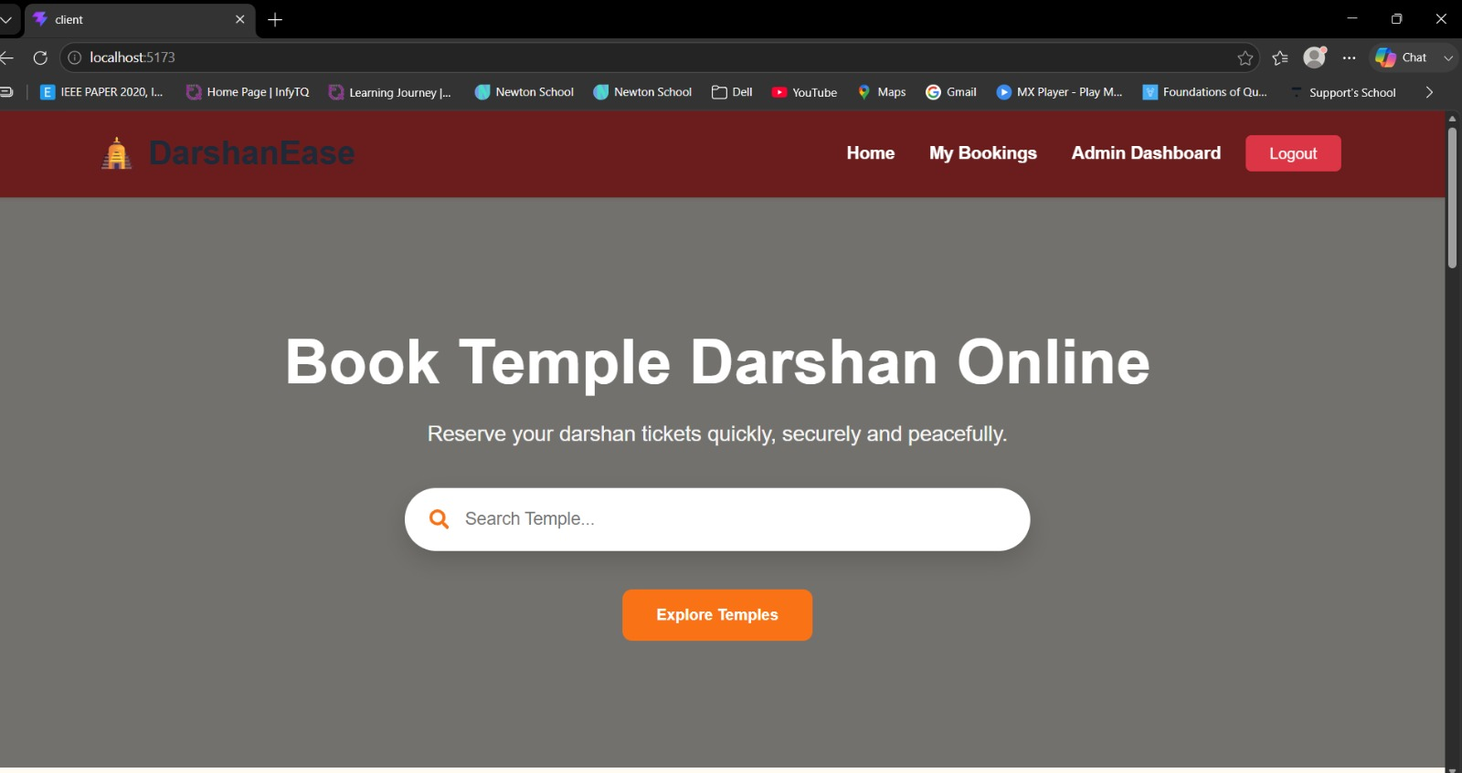
Temple Listing
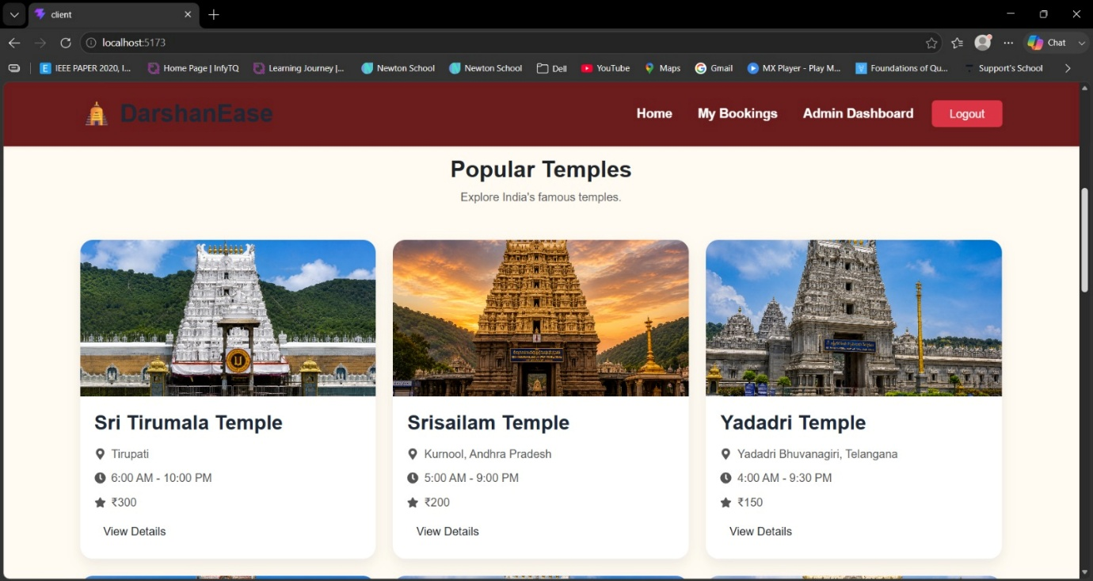

Features & Statistics
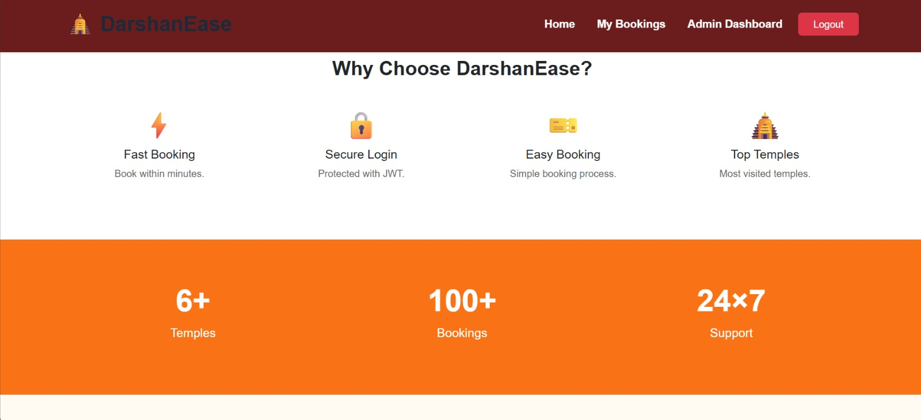

Admin Dashboard
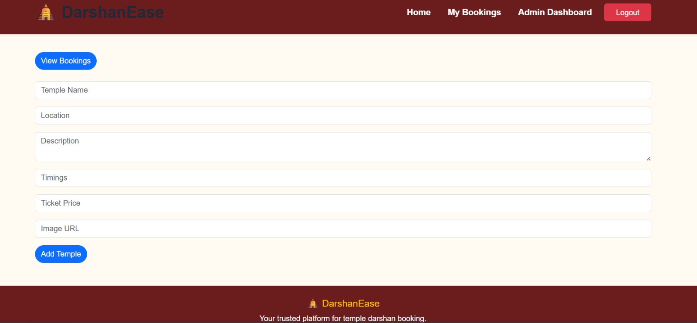
My Bookings
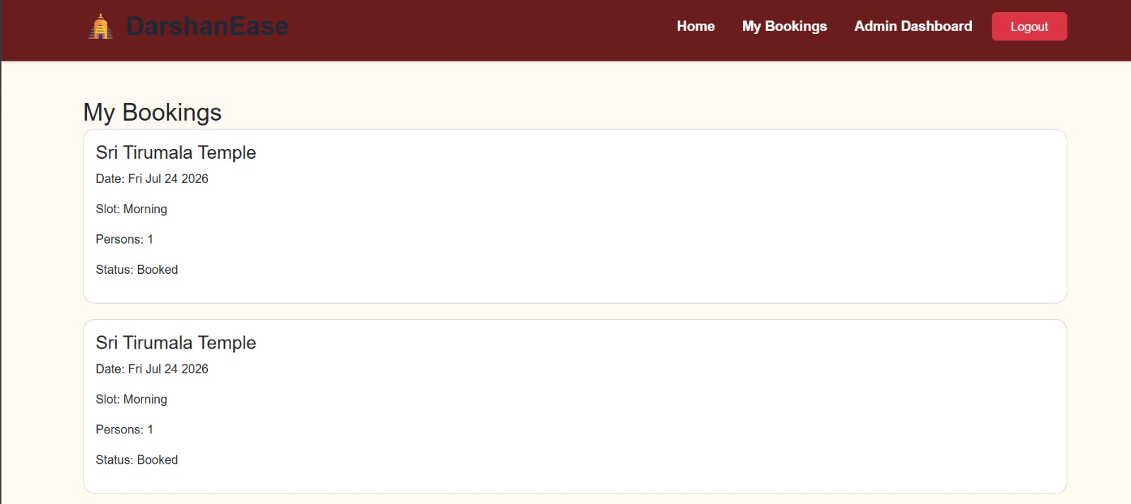

Login Page
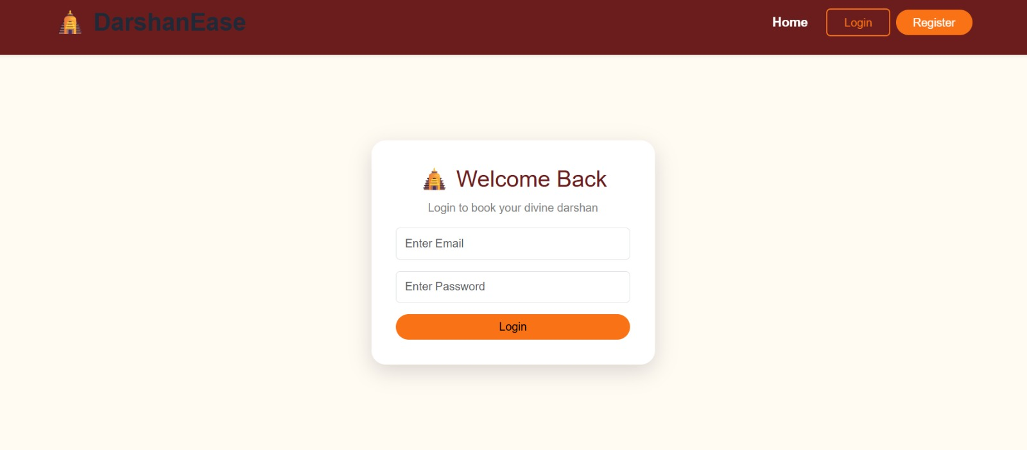

Registration Page
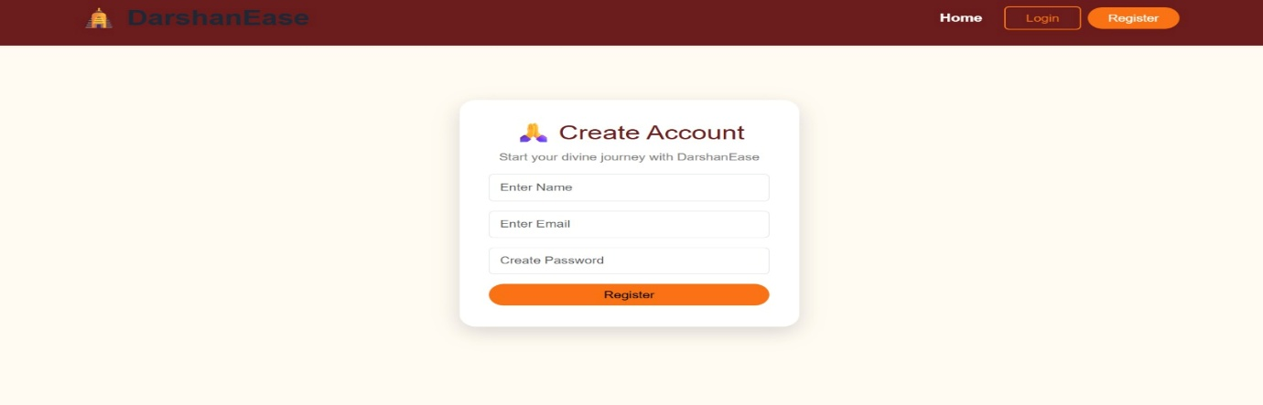

GitHub Repository:
Repository:
https://github.com/ChSaiMounika/my-mern-project

CHAPTER 12
KNOWN ISSUES
The current version of DarshanEase has the following limitations:
- Stable internet connection is required.
- Payment gateway integration can be improved.
- Email and SMS notifications are not implemented.
- Heavy server traffic may slightly affect performance.
These issues can be addressed in future updates.

CHAPTER 13
FUTURE ENHANCEMENTS
The DarshanEase application can be enhanced with the following features:
- QR Code based ticket verification
- Mobile Application (Android & iOS)
- AI-based crowd prediction
- Online Donation Module
- SMS & Email Notifications
- Multi-language Support
- Google Maps Integration
- Online Payment Gateway
- Analytics Dashboard
- Live Darshan Slot Updates

CONCLUSION
DarshanEase is a secure and user-friendly MERN stack web application that simplifies the temple darshan ticket booking process. The system provides an efficient online platform for devotees to browse temples, reserve darshan slots, and manage bookings while helping administrators organize temple activities effectively.
The application reduces waiting time, improves crowd management, and offers a responsive interface with secure authentication. By utilizing modern web technologies such as React.js, Node.js, Express.js, and MongoDB, the project demonstrates a scalable and reliable solution for digital temple management.

REFERENCES
- MongoDB Documentation – https://www.mongodb.com/docs/
- React Documentation – https://react.dev/
- Node.js Documentation – https://nodejs.org/docs/latest/api/
- Express.js Documentation – https://expressjs.com/
- JSON Web Token (JWT) Documentation – https://jwt.io/
- GitHub Repository – https://github.com/ChSaiMounika/my-mern-project

